**HEXADECIMAL TO DECIMAL CONVERSION**

**EXP NO: 27**

**AIM:**

To write a C program to implement hexadecimal to decimal conversion.

**ALGORITHM:**

1)      Start from the right-most digit. Its weight (or coefficient) is 1.  
2)      Multiply the weight of the position by its digit. Add the product to the result .(0=0, 1=1, 2=2, … 9=9, A=10, B=11, C=12, D=13, E=14,F=15)  
3)      Move one digit to the left. Its weight is 16 times the previous weight.  
4)      Repeat 2 and 3 until you go through all hexadecimal digits.

**PROGRAM:**

#include<stdio.h>

int main(){

int n;

printf("enter the hex decimal number: ");

scanf("%x",&n);

printf("the decimal value is: %d",n);

return 0;

}

**INPUT:**

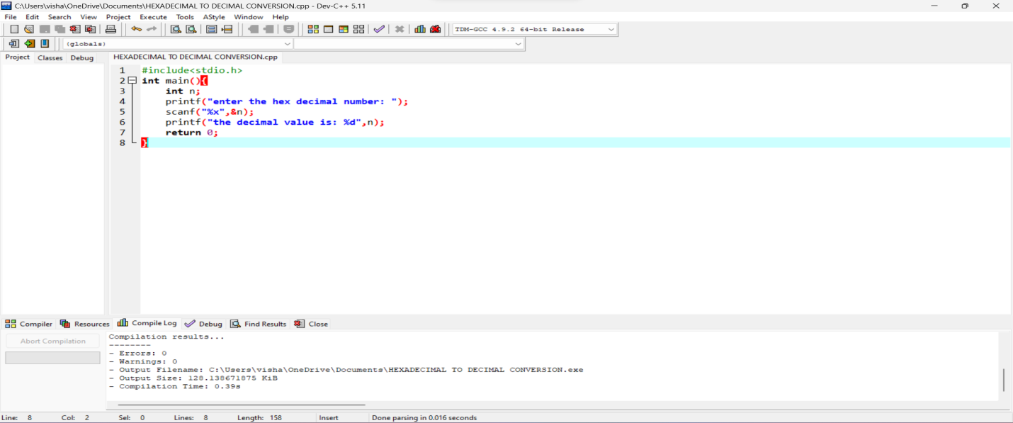

**OUTPUT:**

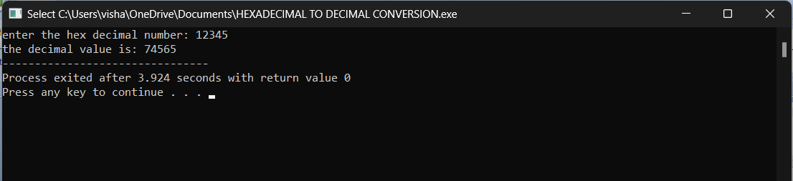

**RESULT:**

Thus the program was executed successfully using DevC++.